EXERCISE 1

Using Visual Studio, create a Form like the one shown in Figure 14-39. Specify a directory on your system, and when the Form loads, list the files to directory contains in a **CheckedListBox. (**You first saw an example of a CheckedListBox in Chapter 12.) Allow the user to click a file’s corresponding check box and display the file’s creation date and time. (Each time the user checks a new filename, display its creation date in place of the original selection.) Save the project as**TestFileAndDirectory2.** Create as many files as necessary to test your program.

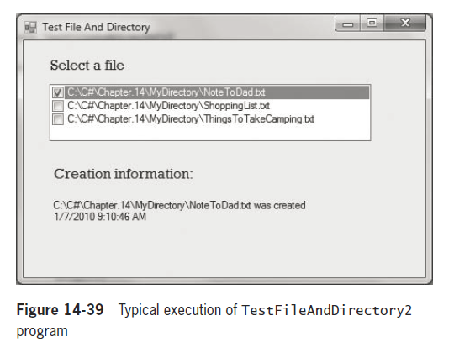

EXERCISE 2

a. Create a program named **WriteInventoryRecords** that allows you to enter data for items you sell at an online auction site and saves the data to a file. Create an Inventory class that contains fields for item number, description, and asking price.

b. Create a program named **ReadInventoryRecords** that reads the file created in Exercise 2a and displays each item’s data on the screen.

c. Create a program named **FindInventoryRecords** that prompts the user for an item number, read the file created in Exercise 2a, and displays data for the specified record.

d. Create a program named **FindInventoryRecord2** that prompts the user for a minimum selling price, reads the file created in Exercise 2a, and displays all the records containing a price greater than or equal to the entered price.

Exercise 3

Create a program named **CustomizeAForm** that includes a Form for which a user can select options for the background color, size and title The Form should look like the one shown in Figure 14-40. Change each feature of the Form as the user makes selections. After the user clicks the “Save form settings” Button, save the color, size and title as strings to a file and disable the button.

